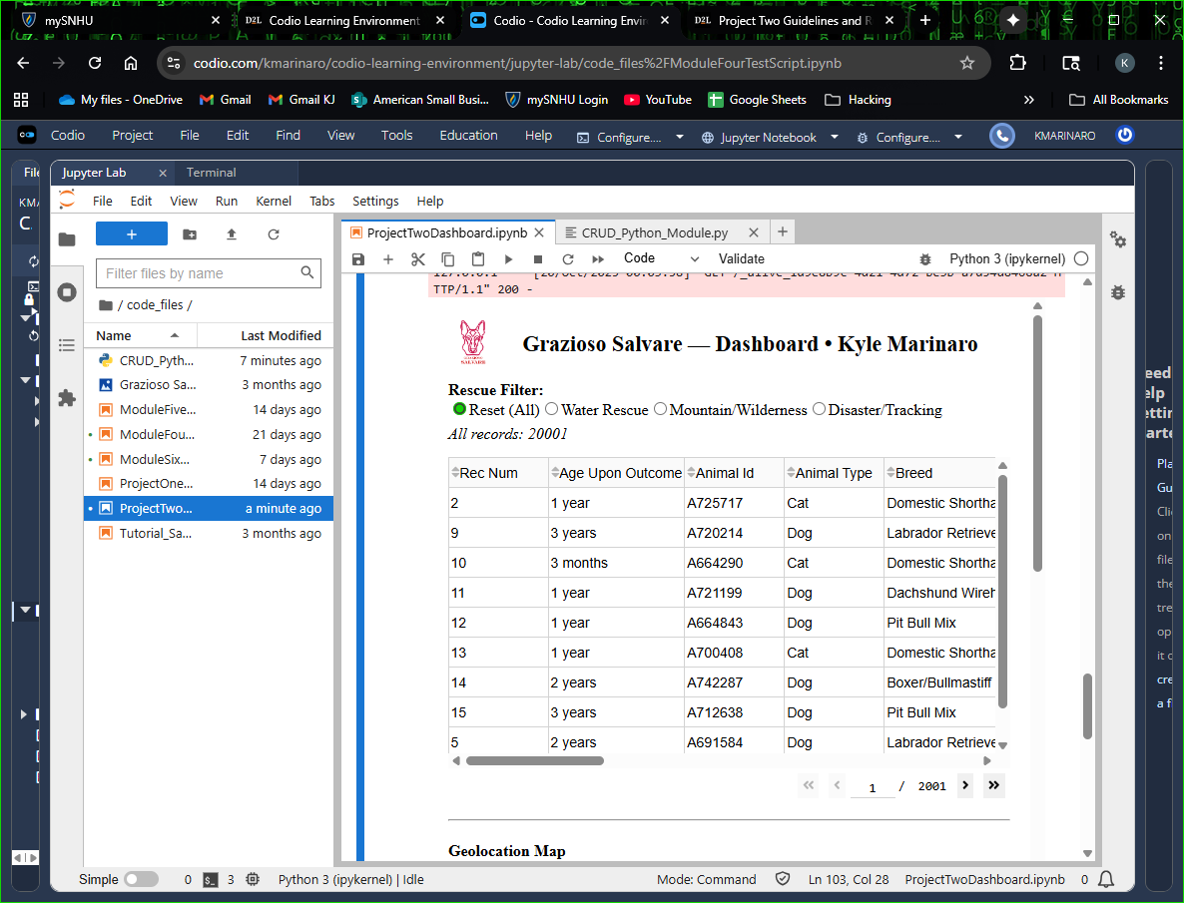
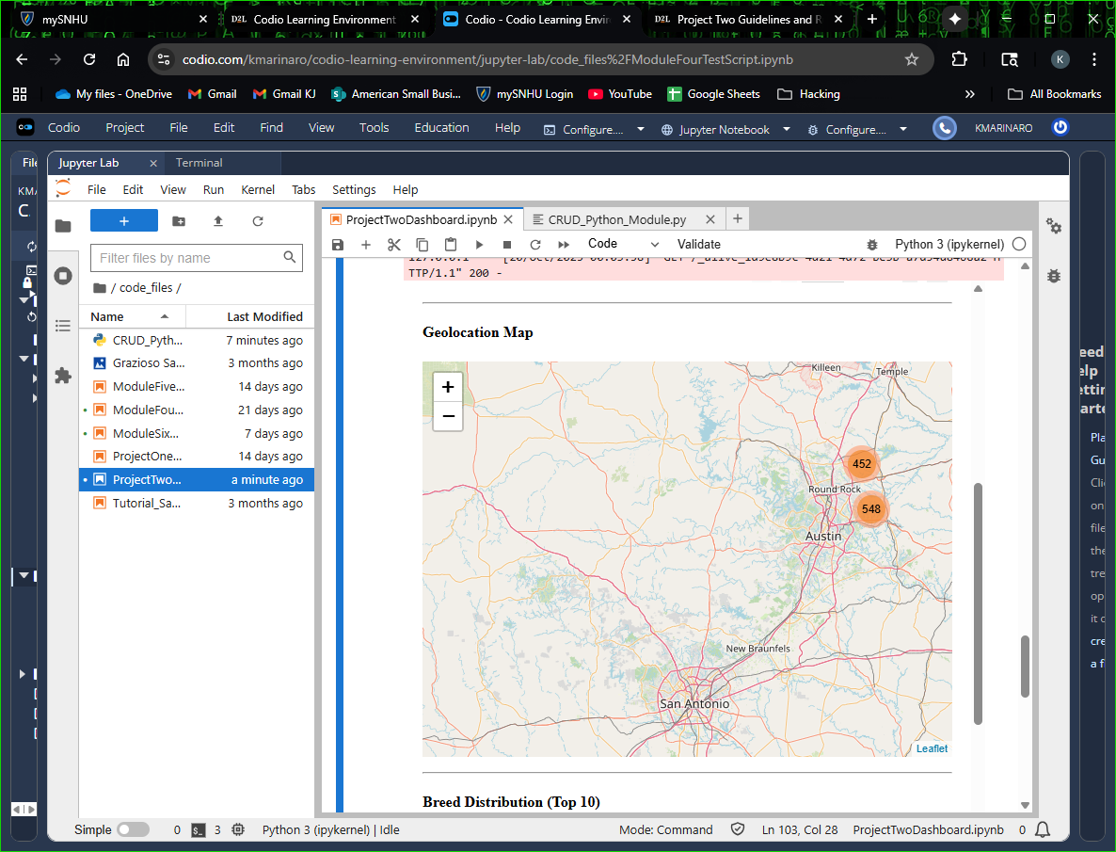
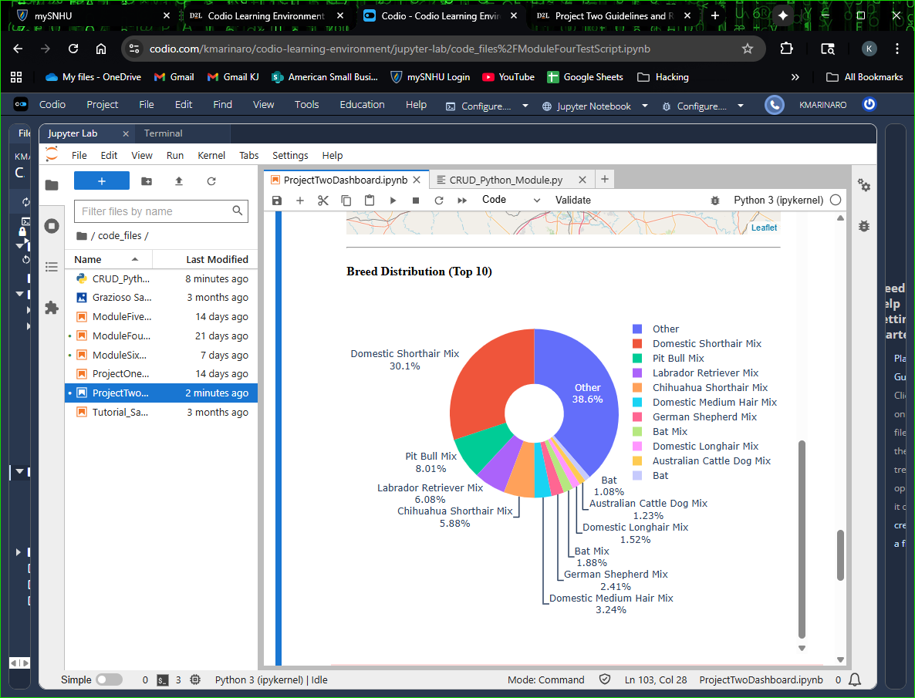
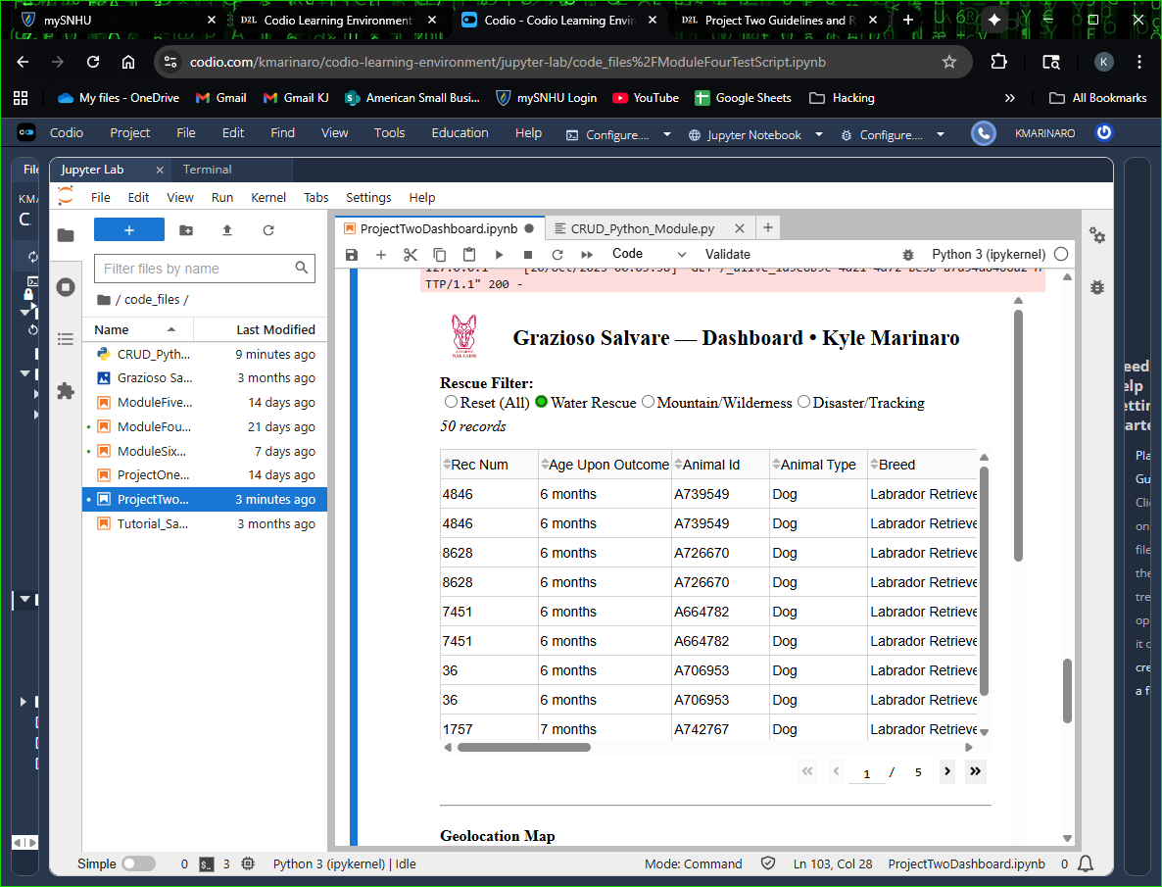
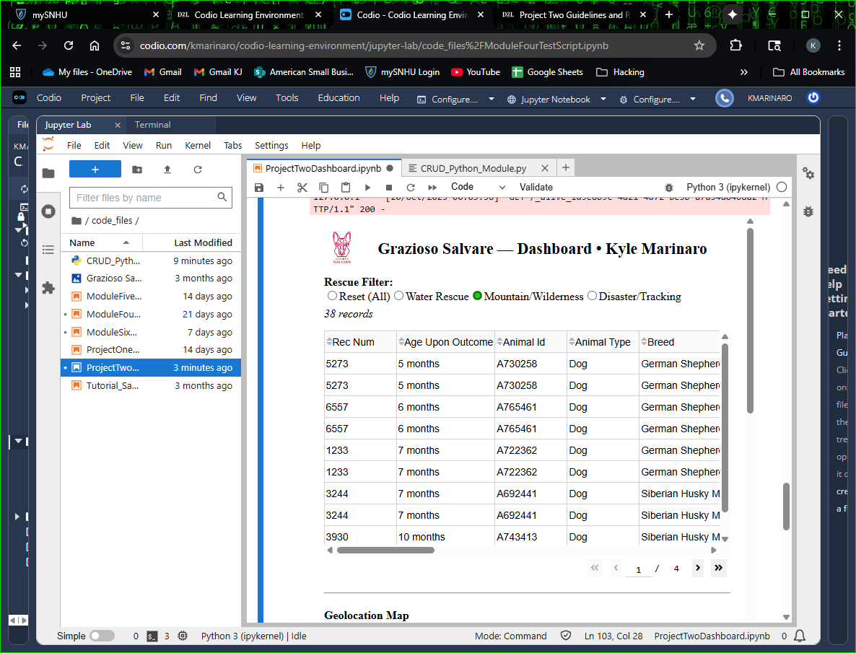
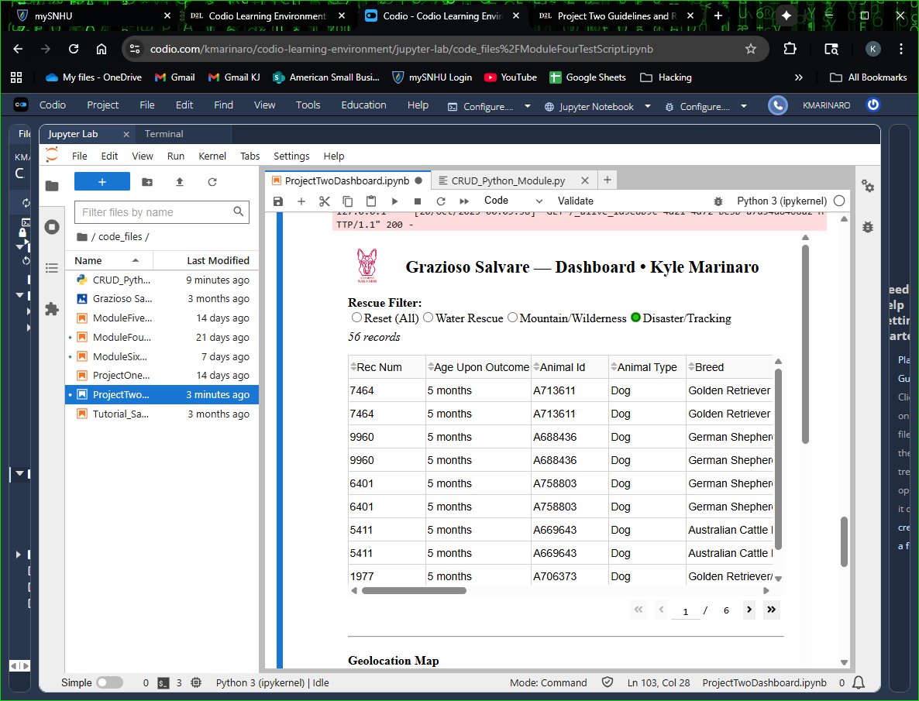
# Grazioso Salvare – Project Two Dashboard
**Developer:** Kyle Marinaro
**Course:** CS-340 – Client/Server Development
**Environment:** Codio Jupyter Notebook with Python, Dash, and MongoDB

---

## 📖 Overview
This project implements a data dashboard for Grazioso Salvare, an animal-rescue organization that identifies dogs suitable for specific rescue training programs.
The dashboard connects to a MongoDB database using a custom `CRUD_Python_Module.py` and displays data in an interactive web interface.

The dashboard allows users to:
- Filter rescue animals by **rescue type** (Water Rescue, Mountain/Wilderness, Disaster/Tracking)
- View a live **data table** with adoption details
- See an interactive **geolocation map** of animal coordinates
- Display a **breed distribution pie chart**

---

## ⚙️ Files
| File | Description |
|------|--------------|
| `CRUD_Python_Module.py` | Provides Create, Read, Update, Delete operations for MongoDB |
| `ProjectTwoDashboard.ipynb` | Jupyter Notebook containing the interactive Dash dashboard |
| `ModuleFourTestScript.ipynb` | Test script used to verify CRUD operations |
| `README.md` | This documentation file |

---

## 🖥️ How to Run
1. Open **ProjectTwoDashboard.ipynb** in Codio.
2. Run all cells from the top (Shift + Enter).
3. The dashboard will appear inline at the bottom of the notebook.
4. Use the radio buttons to select a **Rescue Filter**:
- Reset (All)
- Water Rescue
- Mountain/Wilderness
- Disaster/Tracking
5. The table, map, and pie chart update dynamically.

---

## 📊 Features Demonstrated
- MongoDB data access through PyMongo
- Interactive Dash components (DataTable, Leaflet Map, Plotly Pie)
- Callback-driven UI updates
- Clean, readable layout with inline display in Jupyter

---

## 🧠 Key Learning Reflections
- Practiced connecting a Python backend to a live MongoDB instance.
- Learned how Dash callbacks dynamically link user input to data visuals.
- Improved debugging skills by resolving runtime warnings and ID conflicts.
- Gained experience deploying analytical dashboards in Jupyter.

---

## 📸 Screenshots
Include screenshots named like:
1. `dashboard_all.png` – Full dashboard view (All records)
2. `dashboard_water.png` – Water Rescue filter selected
3. `dashboard_mountain.png` – Mountain/Wilderness filter
4. `dashboard_disaster.png` – Disaster/Tracking filter
5. `dashboard_pie_map.png` – Map and Pie chart shown

---

## ✅ Verification Checklist
- [x] Dashboard runs without error
- [x] Table, map, and pie chart display correctly
- [x] Filters update data dynamically
- [x] Name and project title visible
- [x] Screenshots attached for submission

---

### End of README

